Instructions to connect your OneDrive account to the Desktop PC.
Step 1: Log into your school email account and click on the apps icon. Select OneDrive.
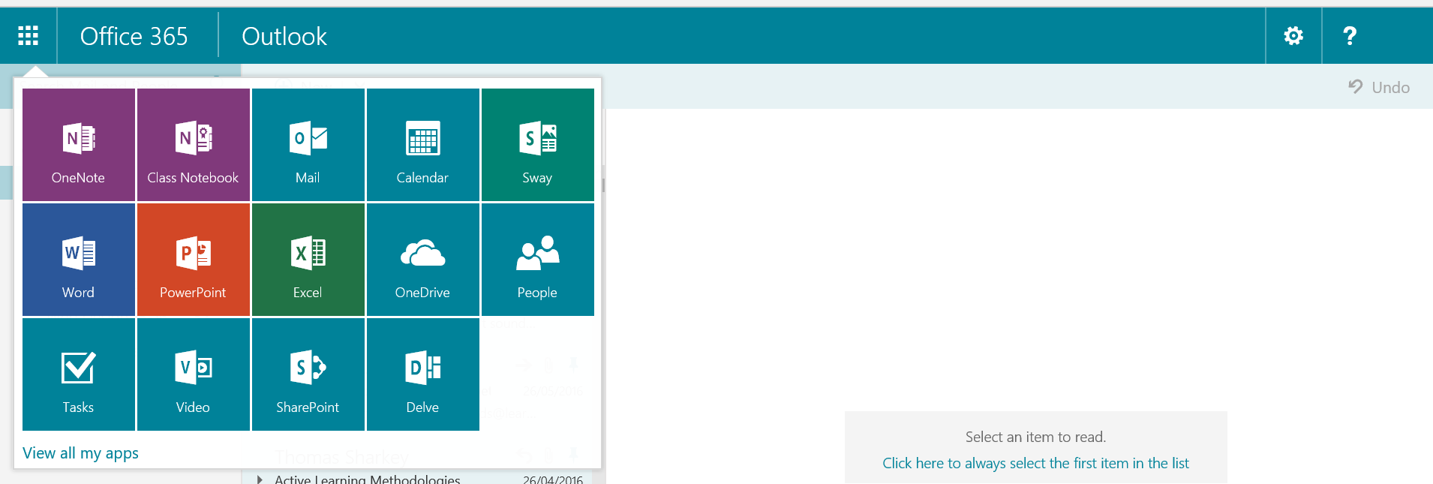

Step 2: Click on the “Sync” from the options at the top of the page.

Step 3: Click “Sync Now” in the pop up message box.
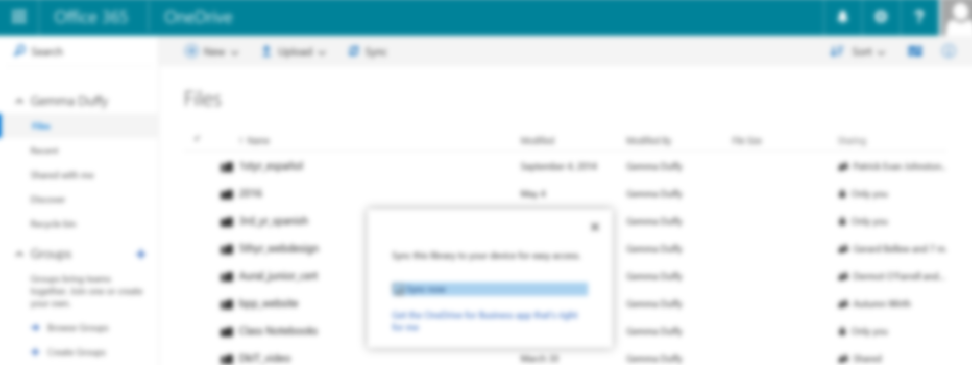

Step 4: Click “show my files” from the pop up box
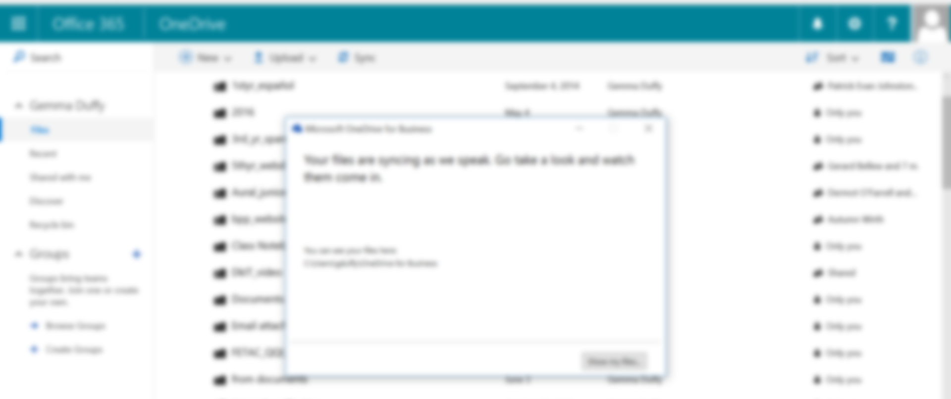

Step 5: on the taskbar at the bottom of the screen, there should be a cloud icon, right click on this icon and select “Pin to Taskbar”. This will ensure that the icon is always there. If the icon does not appear on the taskbar, it can still be easily accessed through your Desktop.
